Question 1

N = $N_{3} N_{2} N_{1} N_{0}$

 |  |  |  | $$N_{3}$$ | $$N_{2}$$ | $$N_{1}$$ | $$N_{0}$$
 |  |  |  | $$N_{3}$$ | $$N_{2}$$ | $$N_{1}$$ | $$N_{0}$$
 |  |  |  | $$N_{0}N_{3}$$ | $$N_{0}N_{2}$$ | $$N_{0}N_{1}$$ | $$N_{0}N_{0}$$
 |  |  | $$N_{1}N_{3}$$ | $$N_{1}N_{2}$$ | $$N_{1}N_{1}$$ | $$N_{1}N_{0}$$
 |  | $$N_{2}N_{3}$$ | $$N_{2}N_{2}$$ | $$N_{2}N_{1}$$ | $$N_{2}N_{0}$$
 | $$N_{3}N_{3}$$ | $$N_{3}N_{2}$$ | $$N_{3}N_{1}$$ | $$N_{3}N_{0}$$
 | $$N_{3}N_{2}$$ | $$N_{1}N_{3}$$ | $$N_{0}N_{3}$$ | $$N_{0}N_{2}$$ | $$N_{1}N_{0}$$ | 0 | $$N_{0}$$
 | $$N_{3}$$ |  | $$N_{2}N_{1}$$ |  | $$N_{1}$$
 |  |  | $$N_{2}$$
$$P_{8}$$
$$P_{7}$$
$$P_{6}$$
$$P_{5}$$
$$P_{4}$$
$$P_{3}$$
$$P_{2}$$
$$P_{1}$$
$$0$$
$$N_{0}$$
$$N_{3}$$

$$N_{1}N_{3}$$

$$N_{3}N_{2}$$

$$N_{2}$$
HA

FA

FA
$$N_{0}N_{3}$$

$$N_{2}N_{1}$$

FA
$$N_{0}N_{2}$$

HA
$$N_{1}N_{0}$$

$$N_{1}$$
HA

Area = 3 Half Adders + 3 Full Adders + AND Gate
Delay = 3$t_{ha}$ + 3$t_{fa}$ + AND Gate delay
Implementation of 1011:

$$0$$
$$1$$
1
$$1$$
$$1$$
$$0$$
$$0$$
$$1$$
$$0$$
$$1$$
$$1$$

$$0$$

$$0$$
HA

FA

FA
$$1$$

$$0$$

FA
$$0$$

HA
$$1$$

$$1$$
HA

$$1$$

$$0$$

$$1$$

$$1$$

$$0$$

$$0$$

$$0$$

$$0$$

P = ${011110010}_{2}$ = ${242}_{10}$

Check $11 × 11 =121 × 2 = {242}_{10}$
Question 2

Let

$P_{i}=A_{i}⨁B_{i}$ 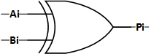

$G_{i}= A_{i}.B_{i}$ 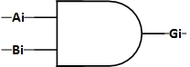

$S_{i}=P_{i}⨁C_{i}$ 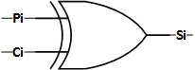

and

$$C_{i+1}=G_{i}+P_{i}C_{i}$$

$$i=0$$ | $$C_{1}=G_{0}+P_{0}C_{0 }=A_{0}B_{0}+P_{0}C_{0}= G_{0}+P_{0}C_{0}$$
$$i=1$$ | $$C_{2}=G_{1}+P_{1}C_{1}=A_{1}B_{1}+P_{1}\left(G_{0}+P_{0}C_{0}\right)= G_{1}+ P_{1}G_{0}+ P_{1}P_{0}C_{0}$$
$$i=2$$ | $$C_{3}=G_{2}+P_{2}C_{2}=G_{2}+ P_{2}(G_{1}+ P_{1}G_{0}+ P_{1}P_{0}C_{0})=G_{2}+P_{2}G_{1}+ {P_{2}P}_{1}G_{0}+ {P_{2}P}_{1}P_{0}C_{0}$$
$$i=3$$ | $$C_{4}=G_{3}+P_{3}C_{3}=G_{3}+ P_{3}\left(G_{2}+P_{2}G_{1}+ {P_{2}P}_{1}G_{0}+ {P_{2}P}_{1}P_{0}C_{0}\right) =G_{3}+P_{3}G_{2}+P_{3}P_{2}G_{1}+ {{P_{3}P}_{2}P}_{1}G_{0}+ {{P_{3}P}_{2}P}_{1}P_{0}C_{0}$$

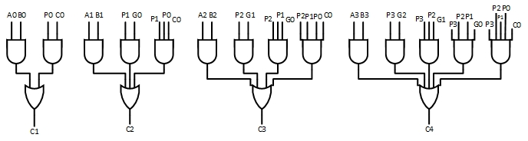
$←$Carry Output

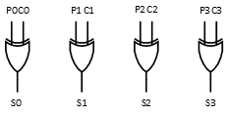
$←$Sum Output

Delay associated with $C_{4}$ is the highest. The path is shown below.
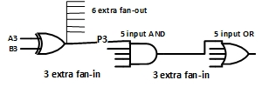
$←$Critical path

$$Total delay = 3+5*\frac{1}{3}+3*\frac{1}{3}+3*\frac{1}{3}=8.0 τ_{g}$$

In comparison, the 4-bit Carry Ripple Adder:
$$S_{0}$$
$$S_{1}$$
$$S_{2}$$
$$S_{3}$$
$$C_{4}$$
$$C_{0}$$
$$A_{1}$$
$$A_{3}$$
$$B_{3}$$
$$A_{2}$$
$$B_{2}$$
$$B_{1}$$
$$B_{0}$$
$$A_{0}$$
FA
FA
FA
FA

$$Total delay = 4 Full adder$$

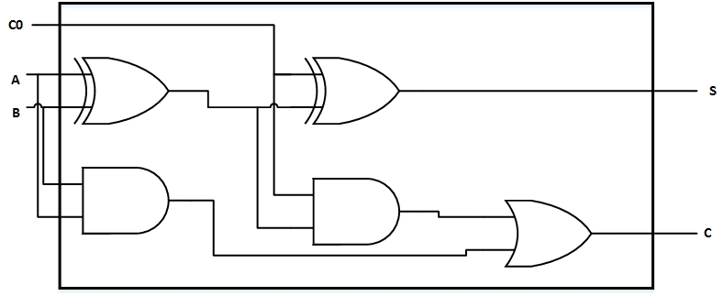
$$\frac{1}{2}t_{g}$$
$$τ_{fa} delay = 3τ_{g}+\frac{1}{2}τ_{g}=3.5 τ_{g}$$
$Total delay = 4*3.5=14.0 τ_{g}$
Question 3

You may design a 8-state FSM with don’t cares or go for a 4-state FSM with decoder for the output which is the simplest as we follow:

State diagram

State |  | Next State |  | Output
$$y_{1}$$ | $$y_{0}$$ | $$y_{1}^{+}$$ | $$y_{0}^{+}$$ | $$O_{3}$$ | $$O_{2}$$ | $$O_{1}$$
0 | 0 | 0 | 1 | 0 | 0 | 1
0 | 1 | 1 | 0 | 0 | 1 | 1
1 | 0 | 1 | 1 | 1 | 0 | 1
1 | 1 | 0 | 0 | 1 | 1 | 1
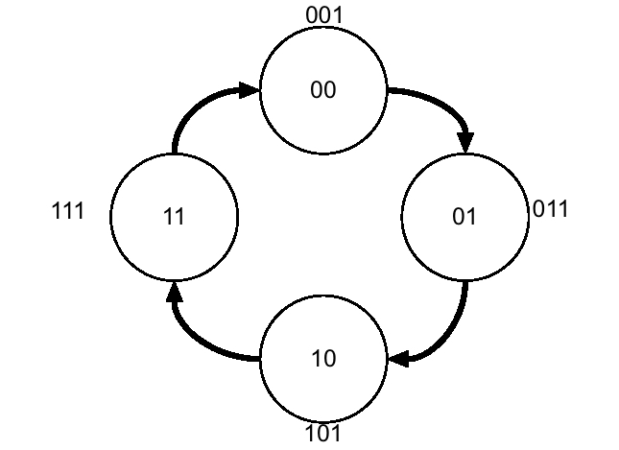

From state table directly the next states and the outputs can be read as:

$$y_{1}^{+}=y_{1}⨁y_{0}$$
$$y_{0}^{+}=\overline{y_{0}}$$

$$O_{3}=y_{1}$$
$$O_{2}=y_{0}$$
$$O_{1}=1$$
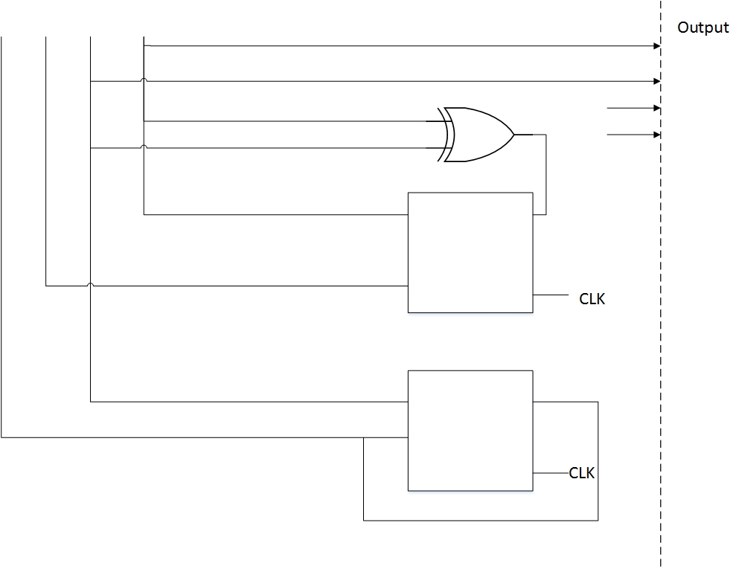
$$O_{2}$$
$$O_{3}$$
$$O_{3}$$
$$y_{0}$$
$$\overline{y_{1}}$$
$$y_{1}$$
$$\overline{y_{0}}$$

Alternatively you might want to design an 8 bit FSM with don’t care states. A ,….. states 000, 010, 100, 110 never happen.

$$y_{2}$$ | $$y_{1}$$ | $$y_{0}$$ | $$y_{2}^{+}$$ | $$y_{1}^{+}$$ | $$y_{0}^{+}$$
0 | 0 | 0 | $$x$$ | $$x$$ | $$x$$
0 | 0 | 1 | 0 | 1 | 1
0 | 1 | 0 | $$x$$ | $$x$$ | $$x$$
0 | 1 | 1 | 1 | 0 | 1
1 | 0 | 0 | $$x$$ | $$x$$ | $$x$$
1 | 0 | 1 | 1 | 1 | 1
1 | 1 | 0 | $$x$$ | $$x$$ | $$x$$
1 | 1 | 1 | 0 | 0 | 1

Giving

$$y_{2}^{+}=y_{1}⨁y_{0}$$
$$y_{1}^{+}=\overline{y_{1}}$$
$$y_{0}=1$$

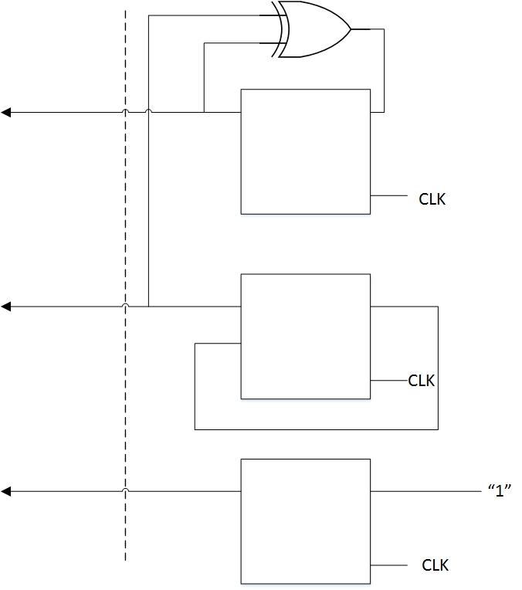
$↑outp$uts = states
$$1$$
$$0$$
$$y_{0}$$
$$y_{1}$$
$$y_{2}$$
$$O_{1}$$
$$O_{2}$$
$$O_{3}$$

