Designing an ALU

Introduction
An ALU (arithmetic-logic unit) is the center core of each central processing unit. It consists of purely combinational logic circuits and performs a set of arithmetic and logic micro operations on two input busses. It has n encoded inputs for selecting which operation to perform. The select lines are decoded within the ALU to provide up to 2^{n} different operations. The ALU we will be building will be capable of up to 14 different operations.

Methodology

Operations of our ALU
S4 | S3 | S2 | S1 | S0 | C_{in} | Operation | Function | Implementation
 |  |  |  |  |  | Arithmetic Unit
0 | 0 | 0 | 0 | 0 | 0 | Y<=A | Transfer A | Arithmetic Unit
0 | 0 | 0 | 0 | 0 | 1 | Y<=A+1 | Increment A | Arithmetic Unit
0 | 0 | 0 | 0 | 1 | 0 | Y<=A+B | Addition | Arithmetic Unit
0 | 0 | 0 | 0 | 1 | 1 | Y<=A+B+1 | Add with carry | Arithmetic Unit
0 | 0 | 0 | 1 | 0 | 0 | Y<=A+/B | A plus 1’s comp. of B | Arithmetic Unit
0 | 0 | 0 | 1 | 0 | 1 | Y<=A+/B+1 | Subtraction | Arithmetic Unit
0 | 0 | 0 | 1 | 1 | 0 | Y<=A-1 | Decrement A | Arithmetic Unit
0 | 0 | 0 | 1 | 1 | 1 | Y<=A | Transfer A | Arithmetic Unit
 |  |  |  |  |  | Logic Unit
0 | 0 | 1 | 0 | 0 | 0 | Y<=A and B | AND | Logic Unit
0 | 0 | 1 | 0 | 1 | 0 | Y<=A or B | OR | Logic Unit
0 | 0 | 1 | 1 | 0 | 0 | Y<=A xor B | XOR | Logic Unit
0 | 0 | 1 | 1 | 1 | 0 | Y<=/A | Complement A | Logic Unit
 |  |  |  |  |  | Shifter
0 | 0 | 0 | 0 | 0 | 0 | Y<=A | Transfer A | Shifter Unit
0 | 1 | 0 | 0 | 0 | 0 | Y<=shl A | Shift left A | Shifter Unit
1 | 0 | 0 | 0 | 0 | 0 | Y<=shr A | Shift right A | Shifter Unit
1 | 1 | 0 | 0 | 0 | 0 | Y<=0 | Transfer 0’s | Shifter Unit

Explanation of select operations of our ALU
Most of these functions will probably be in good memory to you, just to point out some that you might have forgotten:
Y<= A+/B+1 we need the one’s complement of B to A and add 1. According to the table this is equivalent to subtracting B from A. Why does this work? Remember how the 1’s complement of a number is computed, it is: 2^{n}-1-that number. By adding the 1, we thus get A + complement of B here, which equals A – B.
Y<=shl A Just as a reminder here, in case you forgot, to shift left means that every bit is from to 2^{n} to 2^{n+1}, which equals taking the original number * 2
Y<=shr A Basically the opposite of what is happening on a left shift, each number is shifted from 2^{n} to 2^{n-1}, this equals a division by 2.

ALU Number format
You might now think, that an important question to decide when building this state machine is which number format to use, i.e. unsigned, one’s complement, two’s complement. Well, not really. A state machine that can handle unsigned numbers will also handle just as well two’s complement numbers because, as you can either recall or can look up, adding/subtracting is done exactly the same way for two’s complement and for unsigned numbers. The only difference is in the interpretation of the number, i.e. the number 1001 will mean 9 if we are in an unsigned system, it will mean –7 if we are in a 4-bit two’s complement system. So, it is highly recommendable to work with an ‘unsigned’ ALU, especially as in that way you can basically double the positive numbers available to you but, pay attention to what your numbers mean.

Modeling the ALU

Software-View of ALU
This whole table could be modeled using a single case statement, however its synthesized structure would be poor then.
Instead, the ALU has been modeled with a separate arithmetic unit, logic unit and shifter as indicated by the circuit structure below. This modularization is closer to reality, makes it easier to follow the processes and produces better pre-optimized timing.

MUX
Logic
Unit
Arithmetic Unit
Y[3:0]

S[4:3]
S[1:0]
S[4:0]
S[2]

A[3:0]
Logic Unit[3:0]

Shifter
ALU_
NoShift
[7:0]
B[3:0]

Arith Unit[3:0]
Carry-In

This here is already a very advanced, software-oriented model of the ALU as we look at it right from the start as a four bit ALU

Hardware-View of ALU
If we would be looking at it from a hardware perspective, we would have to consider every bit separately in a socalled bit slice. The ALU itself would then be built from an appropriate number of these bit slices which implies a very stringent limit on performance due to the propagation of carries among the ALU stages.
Here as an example hardware schematic of an ALU with two select inputs and one mode input (i.e. three select inputs) that supports the following operations:

S1 | S0 | M | Carry | Function | Comment
 |  |  |  | Logic Operations
0 | 0 | 0 | X | Y<=A | Transfer
0 | 1 | 0 | X | Y<=/A | Complement
1 | 0 | 0 | X | Y<=A XOR B | A XOR B
1 | 1 | 0 | X | Y<=A XNOR B | A XNOR B
 |  |  |  | Arithmetic Operations with Carry = 0
0 | 0 | 1 | 0 | Y<=A | Transfer
0 | 1 | 1 | 0 | Y<=/A | Complement
1 | 0 | 1 | 0 | Y<=A+B | Sum A and B
1 | 1 | 1 | 0 | Y<=/A+B | Sum of B and complement A
 |  |  |  | Arithmetic Operations with Carry = 1
0 | 0 | 1 | 1 | Y<=A+1 | Transfer with Carry
0 | 1 | 1 | 1 | Y<=/A+1 | Two’s complement of A
1 | 0 | 1 | 1 | Y<=A+B+1 | Add with carry
1 | 1 | 1 | 1 | Y<=/A+B+1 | Subtraction
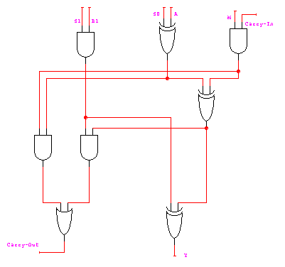
This is now one bit slice that would enable us to build an ALU with the functions described above.
To get an ALU with four bits, we would have to logically connect four of these, for an eight bit ALU eight of these which would certainly amount to quite some work and would also enable numerous errors.
Using a software-oriented approach such as with the Altera Board thus simplifies designs like these extremely.

Designing the ALU in Software
When starting this design it will be most helpful to us if we first look separately at all components of the ALU.

Logic Unit
Let’s start with the Logic Unit. The Logic Unit has as input A and B as well as two of the selector bits. These decide which of the four functions and, or, xor, complement will be used. This is extremely easy, as the functions AND, OR, XOR and NOT are part of the standard VHDL used in Max+plusII, a simple case statement will thus be enough here.

Arithmetic Unit
The same logic as applied for the logic unit can also be used for the Arithmetic Unit. The data inputs are again A and B, as selectors S0, S1 and the Carry-In Bit are used. ‘+’, ‘-‘ and ‘not’ as functions should be enough to implement this block.

Multiplexer
The outputs from these units are then fed into a Mux, which based on S2 will decide which of its inputs will be fed to the Shifter.

Shifter
Based on S4 and S3, the shifter will then either send the input through unchanged or shift it appropriately. Should you not be aware of the VHDL-syntax needed for shifting a shift-register, you can also help yourself by declaring two help registers. In these you can copy the appropriate parts of the original register and fill up the remainder-cell with zeros.

Working with the Altera Software
We have now covered the basic design steps involved in this lab, so that you should be able to come up with a basic layout of the program and can start writing the VHDL code.
When starting to write the program go to the ‘assign’ menu, ‘device’ and select as family ‘MAX7000S’ and the EPM7128SLC84-7 as device.
After you have done that and saved your file for the first time, an .acf file will have been created. Open up the file and in the first begin-end block (it should also contain the information about your device) enter your io- terms and the pins you want to assign to them.

Here an excerpt to show the syntax.
BEGIN
|PB1_DEBOUNCED_SYNC_OUT : PIN = 46;
|PB1_OUT : PIN = 50;
|SLOW_CLOCK_OUT : PIN = 49;
|PB1_SINGLE_PULSE : PIN = 48;
DEVICE = EPM7128SLC84-7;
END;

You also have to pay attention to the fact that a lot of the pins on the chip are already pre-assigned, e.g. for connections to the JTAG-programming header, or for Vcc and Ground. (Check your Altera University Package User Guide)
To make sure that you are not accidentially assigning an output to any one of these pins, after compiling your project, check the *.rpt file that will be created.

Should any of the pins have two terms assigned to them, you have to change your pin-assignments. (This is also why we assign the pins manually. When we assign them automatically, sometimes unluckily double assignments occur that might cause problems)
R R R R R R R R R
E E E E E E E E E
S S S S S S S V S S L
E E E E E E E C R C E E S V L L L
R R R R R R R C E L R R B C S S S
V V V V G V V V I G S G O G V V _ C B B B
E E E E N E E E N N E N C N E E d I _ _ _
D D D D D D D D T D T D K D D D p O g e f
-----------------------------------------------------------------_
/ 11 10 9 8 7 6 5 4 3 2 1 84 83 82 81 80 79 78 77 76 75 |
RESERVED | 12 74 | LSB_d
VCCIO | 13 73 | LSB_c
#TDI | 14 72 | GND
RESERVED | 15 71 | #TDO
RESERVED | 16 70 | LSB_b
RESERVED | 17 69 | LSB_a
RESERVED | 18 68 | MSB_dp
GND | 19 67 | MSB_g
RESERVED | 20 66 | VCCIO
RESERVED | 21 65 | MSB_f
RESERVED | 22 EPM7128SLC84-7 64 | MSB_e
#TMS | 23 63 | MSB_d
RESERVED | 24 62 | #TCK
RESERVED | 25 61 | MSB_c
VCCIO | 26 60 | MSB_b
RESERVED | 27 59 | GND
RESERVED | 28 58 | MSB_a
RESERVED | 29 57 | RESERVED
RESERVED | 30 56 | RESERVED
RESERVED | 31 55 | RESERVED
GND | 32 54 | RESERVED
|_ 33 34 35 36 37 38 39 40 41 42 43 44 45 46 47 48 49 50 51 52 53 _| Pin
Figure 1. Pin Assignment table in *.rpt-file

This is an example of the chip-pin picture that is included in the *.rpt file. Please pay attention here to the fact that pin2 is not GND as shown in the Altera Documentation, pin 4 is GND. It is adviseable, that you always use pin 4 to connect ground to in case you are working with the Logic analyzer.
To visualize the output we will be using the seven segment display of the MAX-chip. The easiest way to do this is to create one register of length 4. This registers can at max. express 16 different numbers, this is also the max. amount of numbers that can be expressed on a single 7-Segment-Display when using the Hex number system and it is also the max number that we might want to output.
The next thing that needs to be done is that you define the content of a register of length seven that stands for the seven segments of the Display, based on the four-bit register.
After this has been done, take a look in the Altera user guide to find out which output pins are connected to which segment and assign appropriate output terms to them.

Attention: The Altera CAD-software is set to a default value that will compile your program in such a way that it will try to optimize both speed and the area in the chip (ie spread out the logic a bit).
When you try to compile this program you must set the compilation to optimize the use of the chip as your design will otherwise not fit on it.
You do this by going to ‘Assign’ and then ‘Global Project Logic Synthesis’. In the window that will subsequently pop up, move the indicator between Area and Speed all the way to Area and set ‘Multi-Level Synthesis for Max5000/7000 design’ to yes.
If this does not make enough space available on the chip for your design, take another look at your equations. You will probably have a lot of additions in them. For each of these additions Max+plusII will create a new adder and thus waste a lot of space. To avoid this, use the generic form A+X and then have another case statement that decides what X is (B or B+1 or….)

Simulation
Now your program is compiled, to make sure that it does what you want it to do, you need to simulate it. (And you need the simulation to get checked off)
To do this, you must have compiled your VHDL-file, and you must have the project set to it. If you go to the ‘File’-menu, select ‘new’ and then the ‘.scf’ extension, a new waveform file will be created for you.
Make sure that you select appropriate values for the end time in the ‘file’-menu and for the grid size in the ‘options’-menu. Now go to ‘Enter Nodes from SNF’ in the ‘nodes’ menu. After you applied the ‘list’ command all io nodes in your file should be shown and you can select these that you want displayed in your simulation file.
Press ‘OK’ to continue.
Now you should be in the default setup of the simulator file.
The next thing is to create a meaningful waveform. Highlighting the node, you can use one of the buttons on the right-hand side of the screen to change the entire waveform to 1,0, clock etc.
You can however also highlight a channel go to ‘Utilities’ -> Selection and select a certain time interval that is to be changed. That way you can e.g. simulate changing one of the dip-switches for a certain time.
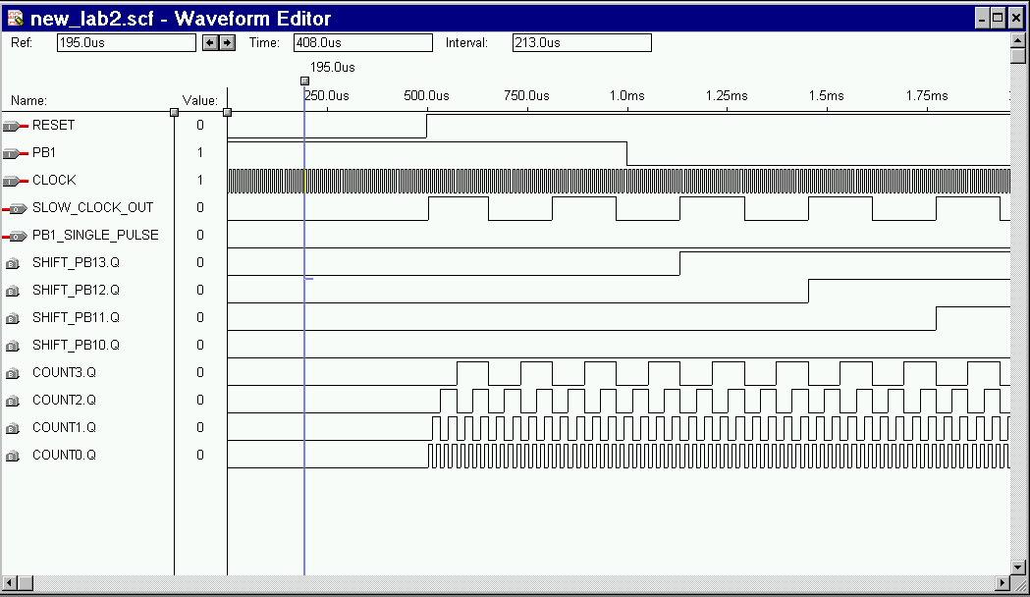Here is a sample simulation, please don’t take this as a literal example. There are other inputs/outputs that might be important to you.
Figure 2. Sample Simulation Waveform file

Programming the Max-Chip
When programming, be sure that you are programming the right chip on the board. You select these through the on-board jumpers. Take a look in the Altera User Guide for the correct configuration. Also, check ‘Hardware Setup’ in the ‘Options’ menu to make sure that you are writing to LPT2.
You are now ready to program. Connect your Altera-board with the byteblaster cable that should be included in the box to LPT2 and hook up the power supply. The MAX-chip is an EEPROM, which means it is erasable and programmable however, it will keep its programming until you reprogram it, so you can conviniently program it in the computer room and then take it outside to connect it to one of the Logic Analyzers.
To program the chip, go to the ‘Max+plus II’ menu and select the programmer. Check the output that appears on the screen especially the device. If everything is okay, press program.
Now you can try out your programmed chip, to see if it behaves as expected.

How you can get more out of your ALU

Carry-Out and Overflow
As we already discussed at the beginning of this tutorial, it is advantageous to act as if your ALU would only deal with unsigned numbers as that way you can also deal with two’s complement numbers. However, there are now two conditions that can mess us up in these systems, carry-out and overflow.

Carry-Out
What is a carry-out (just in case you don’t remember ☺)? Well, the highest number we can display on the 7-Segment display is ‘F’ which symbolizes 15. We get this number for example just by setting all A-switches high when all selection switches and the carry-in switch are low. What happens now if we set the carry-in high, too? Up to now the output register was: ‘1111’. Adding another one now will set it to ‘0000’ and we would have a 1 in the fifth position. As this position however does not exist, this number – our carry-out – is lost. So, what can we do?
Well, quite easy, we can increase the register. However, then we cannot anymore display all the numbers the register can contain on the 7-segment display.
To take care of that, we can use the decimal point of the 7-Segment display to show if we have a carry-out or not and thus we can now display numbers from 0 to 31 instead of only from 0 to 15.

Overflow
Carry-out does of course only make sense when we are dealing with unsigned numbers, when we deal with two’s complement numbers we might get overflow which basically means that our result will have the wrong sign. To exemplify this, assume that you are adding the numbers 1001 and 1011 in 4-bit two’s complement. This means of course, that both numbers are negative, but what is the result here? 0100, a positive number, which is a completely wrong result. There are now several ways to test for overflow however, the easiest one is to follow the rule: ‘When the two numbers coming in, have the same sign-bit, and the number going out has a different one, then overflow has occurred’. Easy, isn’t it? (And works in 99.999..% of all cases a => good enough for what we do at the moment) You can implement this, using the other decimal point on the system however, as already stated at the beginning, always pay attention now to the interpretation of your output. Carry-out is meaningless for signed numbers and overflow for unsigned numbers!

